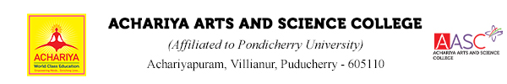
DEPARTMENT OF MULTIMEDIA (VISUAL COMMUNICATION)

DATE: 06.08.2024 LOCATION: EDEN BEACH - PONDICHERRY

Report on the Field Visit

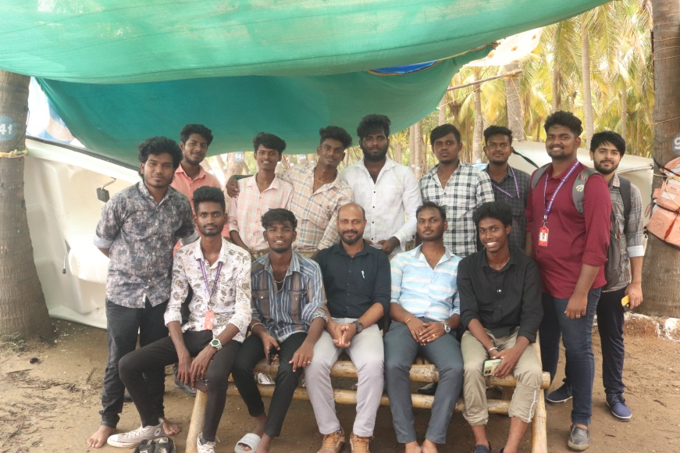
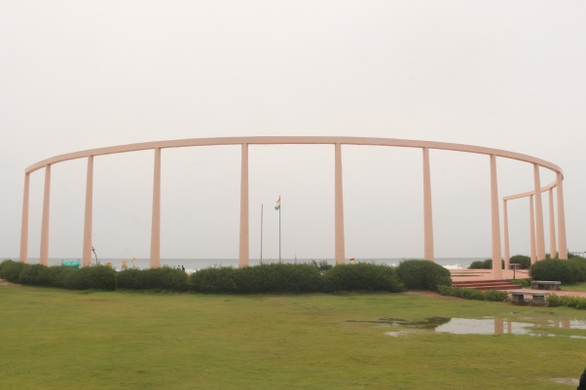
The Department of Multimedia (Visual Communication) visited the Eden Beach on 06.08.2024. The purpose of the visit is to take photographs of the mentioned place for the core subjects Basics of Photography Page Layout And Design and Documentary Production for Ist , II ^{nd} and IIIrd year students.
Department staffs arranged the field visit program and also staffs accompany with students. 25 students participated the programme. The spot is very elegant and highly enjoyable for all.
Flaunting super clean surroundings with sparkling white sand, Eden Beach in Chinna Veerampattinam is a proud blue flag-certified beach in Pondicherry. It is located almost 7 km from the White Town area and the Promenade beach of this city. Also, the well-known Paradise Beach is just 1 km south of this beach. Lying on the east coast of India, Eden Beach offers some mesmerizing sunrise views.
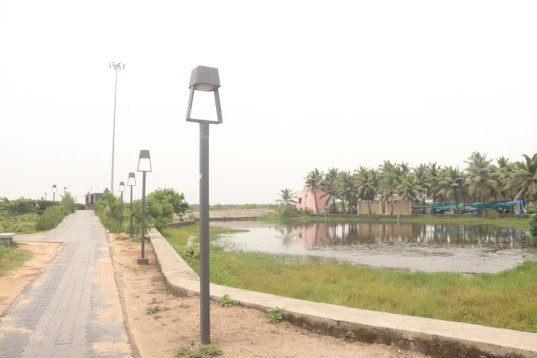
As you arrive at Eden Beach Pondicherry, you will spot the backwaters of the Chunnambar river and thick palm groves, offering a panoramic view. Eden Beach is the first beach in Pondicherry to gain the Blue Flag certification from the Foundation for Environment Education (FEE) in Denmark, which makes it one of the cleanest beaches in India.

Programme Outcome
- Students understand the real-world experience, increase the quality of education, and improve the social relations, outside of the four walls of a classroom.
- Students can able to explain and perform tasks with respect to the various Photographic camera and Learn the skills to take great photography at any time of the day
- Compose a Frame with the knowledge of different lenses and in different lighting.
- Learned how to find the subject for photography
- Learned about natural light, strobe lighting, and supplemental flash
- To create an idea behind this experiential learning is to contextualize knowledge in order to develop a deeper understanding.
- Students understand the report writing for various tourist spot.



DEPARTMENT OF MULTIMEDIA (VISUAL COMMUNICATION)

Photojournalism Workshop Report

DATE: 16.10.2024

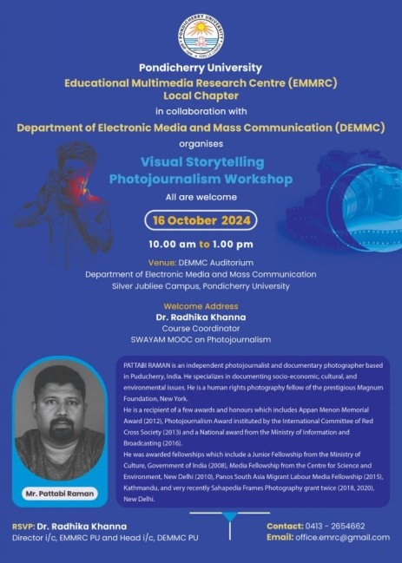
The Pondicherry University, Department of Electronic Media and Mass Communication conduct a Visual storytelling Photojournalism workshop on 16.10.2024. They invited students and faculty members of the department of Multimedia (Visual Communication) to attend the same.
The I, II, III Multimedia (Visual Communication) Twenty Seven students will be the part of the workshop accompanied by Two faculty members (Total 29 members) are participated the program.

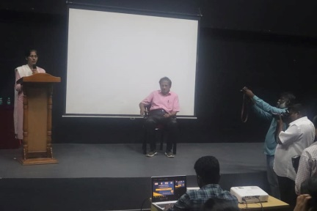
Visual Storytelling Photojournalism Workshop by Mr. Pattabi Raman (Photojournalist) organised by EMRC Pondicherry University Local Chapter in collaboration with DEMMC, Pondicherry University, will explore various forms of storytelling in an editorial context. Through concrete examples of recent reportages or stories and the study of multiple visual languages, it will discuss the means to construct a narrative while reporting on personal stories, as well as on assignments. Imagined as a participative one-day experience, the workshop will also help the participants think about what makes a story, how to document it in a nuanced way, how to navigate challenges or respond to difficulties on the field, and what is involved in reporting on one’s own country or identity.

It acknowledges the contributions of photographers and the impact photography has on our lives by preserving moments and telling stories through images.
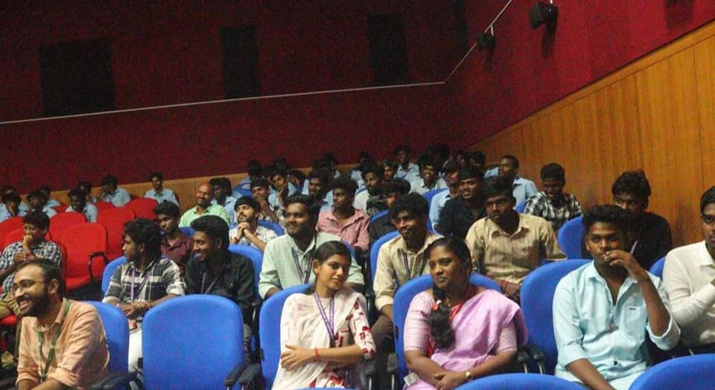

Program Outcome
- Discuss the history of Photography, moving images and Photo Journalism
- Demonstrate a brief understanding of news values, photo journalism and sources.
- Discuss the legal and ethical aspects of photography and photojournalism.
- Assess the importance of digital technology in photography
- Compose a photograph with the knowledge of aesthetic principles
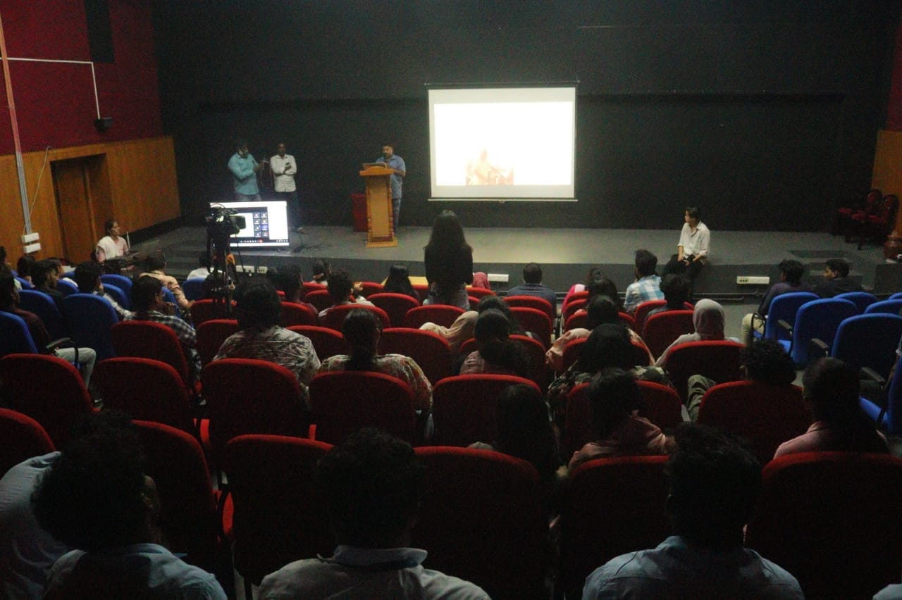



DEPARTMENT OF MULTIMEDIA (VISUAL COMMUNICATION)

Photography Day-Photography Workshop Report

DATE: 19. 08. 2024

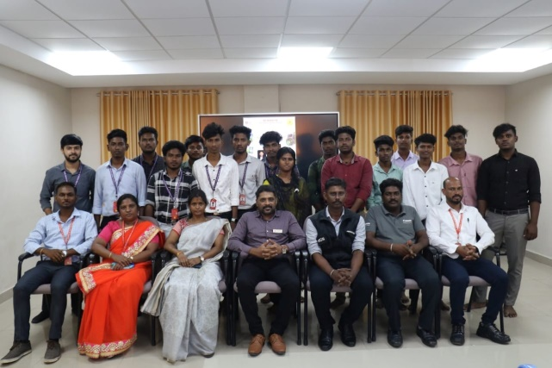
AVM club of Department of Multimedia (Visual Communication), Achariya College of Arts and Science and Canon Company jointly together organized one day Photography Workshop regarding World Photography Day on 19.08.2024 at Achariya Conference hall. This is the most awaited day for all the students of the college. Like the other years, the coordinator of the AVM club of the department published the official notification for all the students along with professors. All the students were requested to participate in the program.
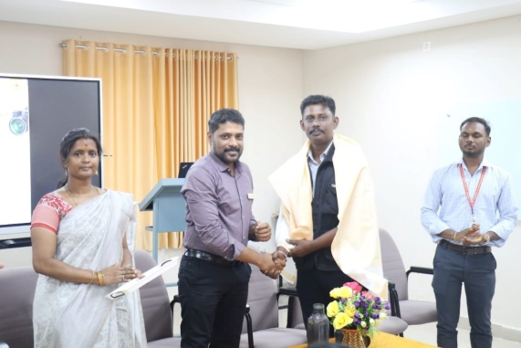
World Photography Day is a global event celebrated on August 19th each year to honor the art, craft, science, and history of photography.
It acknowledges the contributions of photographers and the impact photography has on our lives by preserving moments and telling stories through images.
The program started at Morning 10.00 am in presence our honourable principal Dr. S. Vimal Anand. The Resource person was Mr. Karthikeyan, SSO Canon Trainer for South Tamil Nadu, and Pondicherry. Asst.Prof Mrs. F. Josephine Dayana extended a warm welcome to all the dignitaries present and Mrs. S. Mangaiyarkarasi, Head of the Department, convened the program.
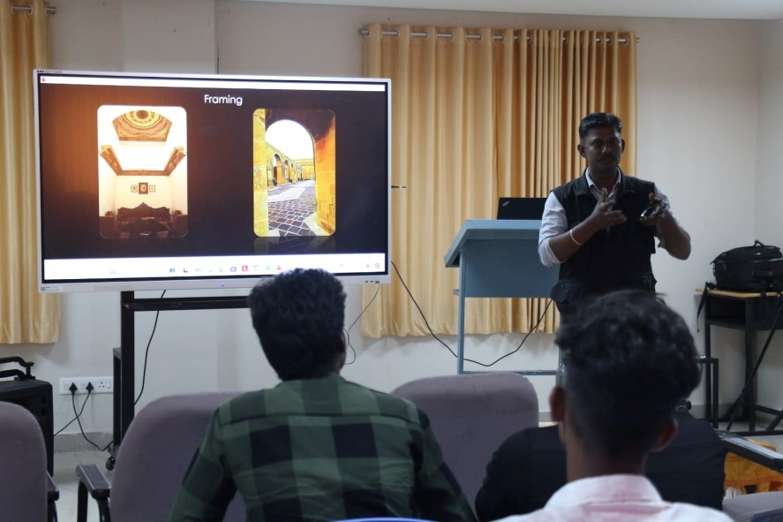
The workshop aimed to enhance the photographic skills of students, provided hands-on experience with different types of cameras and photographic techniques. It inspired the budding photographers to explore their creativity. Students were introduced to different types of cameras, including DSLRs and mirrorless cameras. The facilitator also demonstrated various camera settings. Students were given the opportunity to practice photography under the facilitator's guidance and were encouraged to experiment with different angles, lighting conditions and subjects.
The workshop was well-received by the students, who expressed enthusiasm and eagerness to apply the techniques they learned. The Photography Workshop on World Photography Day was a resounding success, not only enhancing their photographic skills but also fostering a deeper appreciation for the art of photography. Various department students were participated in this workshop. 50 pupils were attend and enjoy the program finally, the department staff Asst. Prof. Mr Dinesh Saravanan thanked to all the dignitaries present. Mr. Vinu. A, Assistant Professor, coordinated the event and neatly arranged the program. The session was more informative and interactive.
Program Outcome
- Demonstrate artistry by creating images that evoke an emotional response.
- Apply Principles of composition to produce Professional images.
- Apply the mechanics of exposure to Control light and influence the final product.


DEPARTMENT OF MULTIMEDIA (VISUAL COMMUNICATION)

DATE: 24. 10. 2024

TELEVISION PRODUCTION WORKSHOP
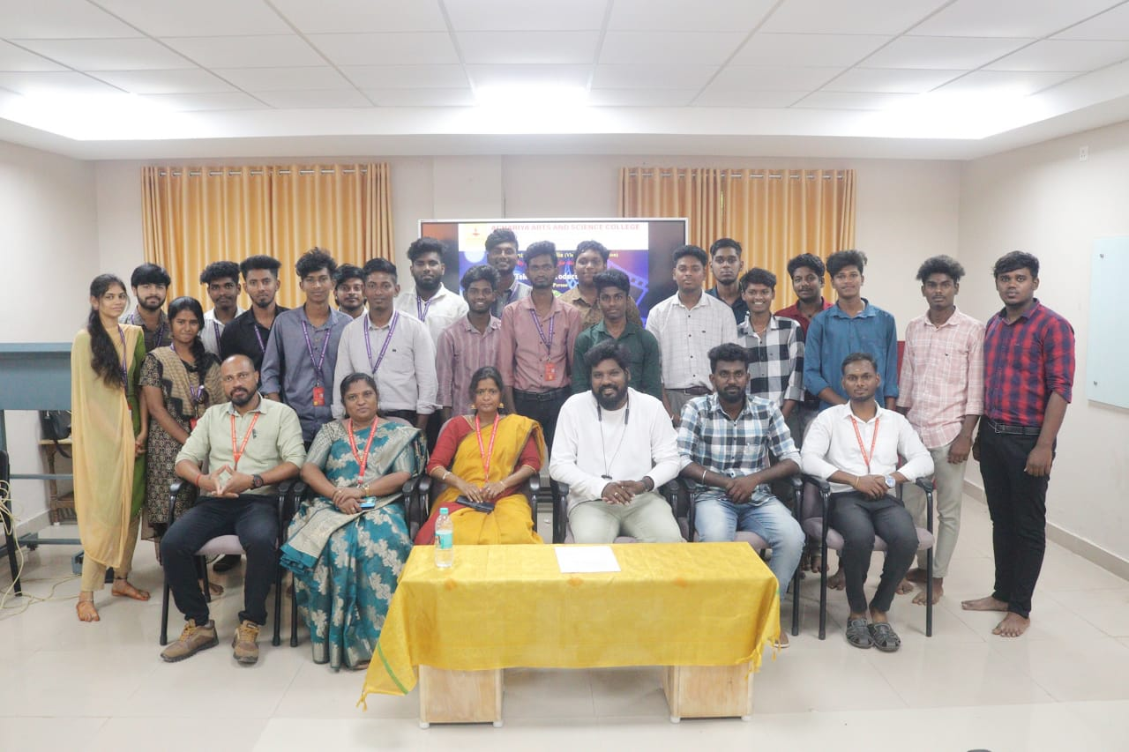
AVM club of Department of Multimedia (Visual Communication), Achariya College of Arts and Science organized one day Television Production Workshop on 24.10.2024 at Achariya Conference hall. This is the most awaited day for all the students of the college. Like the other years, the coordinator of the AVM club of the department published the official notification for all the students along with professors. All the students were requested to participate in the program.

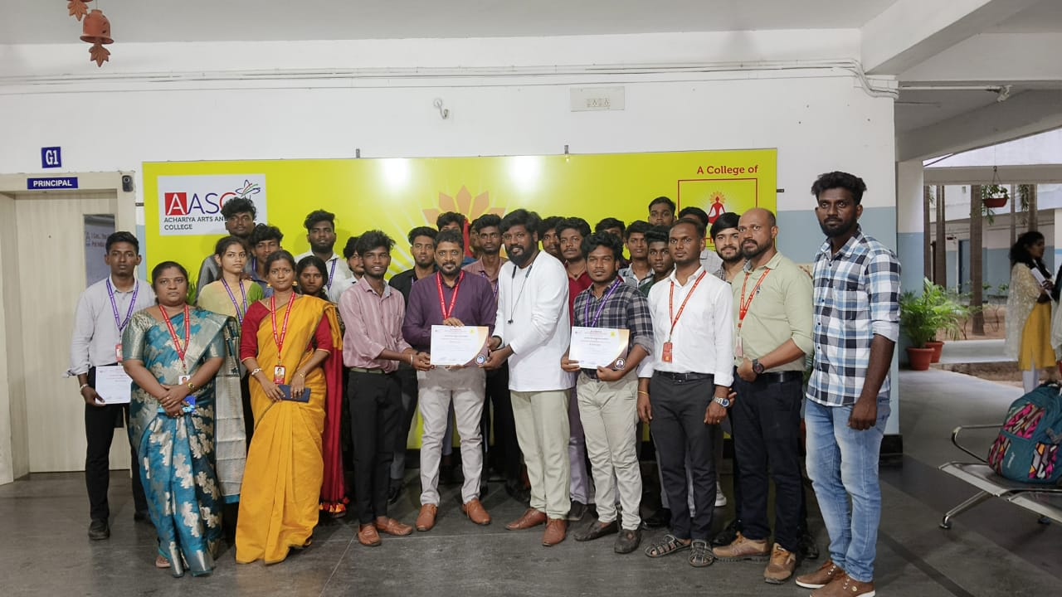
The program started at Morning 10.30am in presence our honourable Dr. Vimal Anand. The Resource person was Mr. Jagan and Mr. Pushparaj, Associate Directors in Film industry . II BSc Viscom student Mis Anchana Sri extended a warm welcome to all the dignitaries present. . Industry experts, Mr. Jagan and Mr. Pushparaj, shared their insights on scripting, camera techniques, lighting, sound, and editing, offering practical demonstrations and engaged in discussions. Our students actively participated in group exercises, gaining valuable skills and knowledge. The workshop concluded with Q&A session, where participants had the opportunity to clarify their doubts and receive expert advice on improving their television production projects.
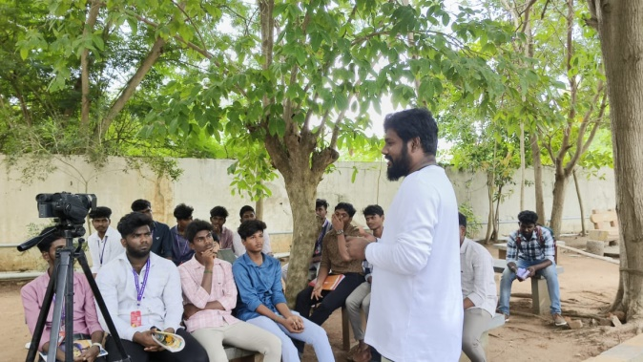
30pupils were attend and enjoy the program finally, the department staff Asst. Prof. Mrs. Josphine Dayna thanked to all the dignitaries present. Faculty members were neatly arranged the program. The session was more informative and interactive.
Program Outcome
- Providing participants with hands-on experience in various stages of TV production
- Apply Principles of composition to produce Professional images.
- Apply the mechanics of exposure to Control light and influence the final product.


DEPARTMENT OF MULTIMEDIA (VISUAL COMMUNICATION)

DATE: 28. 08. 20234
Report on the Web Designing Workshop
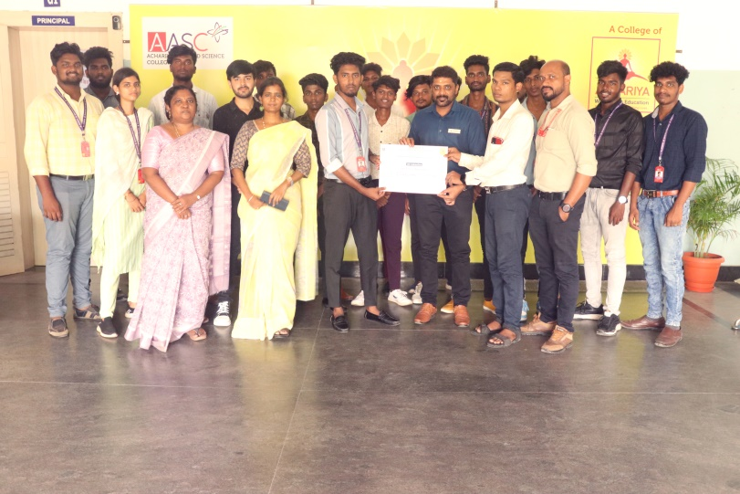
The Department of Multimedia (Visual Communication), Achariya College of Arts and Science organized three days 3D animation workshop (Blender) on 28.08.2024 to 30.08.2024 at visual Communication Multi Media Lab.
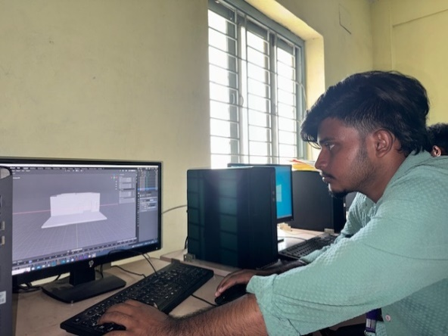
Blender is the free and open source 3D creation suite. It supports the entirety of the 3D pipeline—modelling, rigging, animation, simulation, rendering, compositing and motion tracking, even video editing and game creation.
The program started at Morning 10.00 am in presence our honourable principal Dr. S. Vimal Anand. The resource person was Mr. K. GOKUL, Animator & Graphic designer, E.S Arts and Science College, Vilippuram. Asst.Prof Mrs. F. Josephine Dayana extended a warm welcome to all the dignitaries present and Mrs. S. Mangaiyarkarasi, Head of the Department, convened the program.The Chief Guest congratulated the department for taking such an edifying topic which requires a quick moral action on everybody’s part. Twenty five members participated the workshop and learn modelling in blender.
The three days’ workshop is very useful to develop animation skills of students.
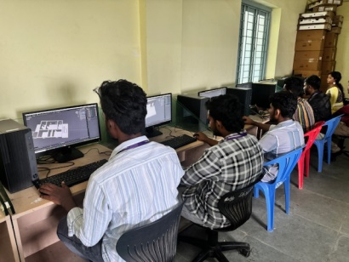
Programme Outcome
- Learn how to create 3D models.
- Discover some of the applications of 3D modelling.
- Design and create their own 3D model.


PHOTOGRAPHY FIELD TRIP
DATE: 09.04.2025 LOCATION: Art & Craft Village - Pondicherry
Department of Visual communication went for a field trip to ART AND CRAFT VILLAGE on (09.04.25) along with the staff members Mr. A. Vinu
The aim of this trip was to enhance the students knowledge and their creative mind aesthetically. Students were benefited positively and thoughtfully.

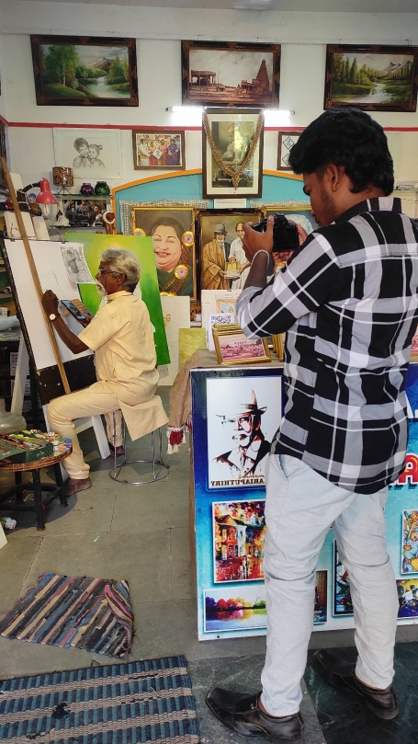
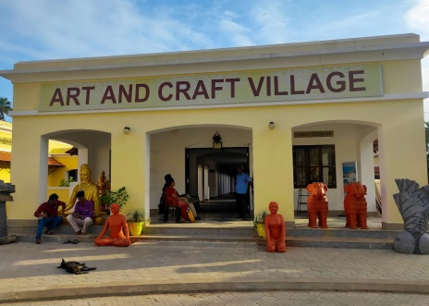
Art and Craft Village Pondicherry is one of the must-visit tourist places. Pondicherry, a little France in India, has many tourist spots to visit, like beaches, parks, boating, and many more activities. Art and Craft Village Pondicherry cover more activities like boating, sightseeing, mangrove ride, arikemedu visit, harbour visit, arts and crafts. With mangrove forest around, the beautiful river flows, catching our attention, giving a feast to our eyes, with an old bridge built during the French regime, bein g a heritage of Pondicherry, and next to it a new bridge with highway road with lights, where you can see the tradition and modern meet, and you can see people walking on its pavements during morning and evening capturing the beautiful sight of the sky, water, bridg e, and the mangroves, sunrises, sunsets
, and moon-light.
Enter the Village, we are welcomed by Big clay sculptures arranged in rows. They were made during arts festival time and are retained here in the Village. Stalls on either side of the Village will be busy making their crafts. On the right-hand side, you will see stalls like handmade kalamkari-styled bags made there. They have been running this stall from the day this Village was open. They have handbags, small hand purses etc.
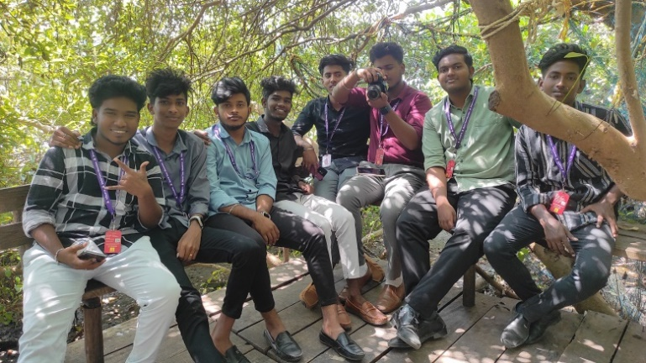
The stall on the left side of the entrance makes coconut shell decorative items for the homes. From earrings to decorative lamps, everything is made from coconut shells. Pondicherry is famous for leather bags, and the iconic Hidesign brand originated here. Next to that coconut shell stall, we can see the leather bag stall. Most of the bags will be hard leather, which is durable and cheap. Stalls make paper lamps, wooden toys, paintings, stone works, handmade hammocks etc., were spread across the Village.
Department staffs arranged the field visit program and also staffs accompany with students. 25 students participated the programme. The spot is very elegant and highly enjoyable for all.
Programme Outcome
- Students understand the real-world experience, increase the quality of education, and improve the social relations, outside of the four walls of a classroom.
- Students can able to explain and perform tasks with respect to the various Photographic camera and Learn the skills to take great photography at any time of the day


DEPARTMENT OF MULTIMEDIA (VISUAL COMMUNICATION)

DATE: 12.02.2025 LOCATION: Pondy marina and Auroville - Pondicherry

Report on the Field Visit

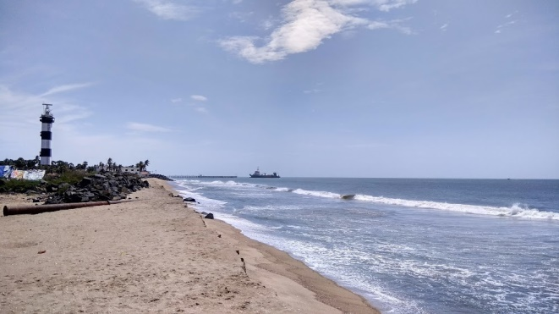
The Department of Multimedia (Visual Communication) visited the Pondy marina and Auroville on 12.02.2025. The purpose of the visit is to take photographs of the mentioned place for the core subjects BASICS OF PHOTOGRAPHY PAGE LAYOUT AND DESIGN and DOCUMENTARY PRODUCTION for Ist , II ^{nd} and IIIrd year students.
Pondy Marina Beach in Pondicherry is the new tourist attraction near the new lighthouse. It was developed under the theme-based beaches programs by the Pondicherry government, and “Pondy Marina” beach is based on a food-based theme.
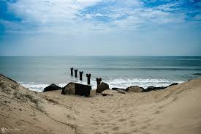
Pondy Marina Beach is located at Dubrayanpet, 1.5km from the White town, Pondicherry. Unlike the rock beach, where the tourists can hardly venture into the seashores, here, as the name suggests, there is a reasonable length of sandy beach. Pondy Marina offers various food options, such as mangrove forest boating, sandy beaches, river mouth sighting, mangrove forest boating, etc. Pondy Marina is one of the best places to see sunrise in Pondicherry.
Auroville is a universal township in the making for a population of up to 50,000 people from around the world.
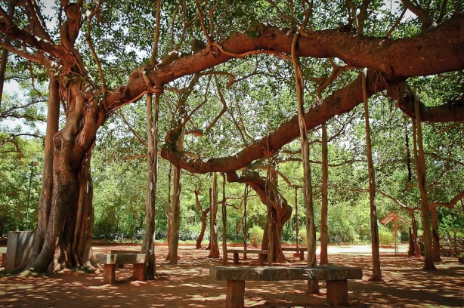
The concept of Auroville - an ideal township devoted to an experiment in human unity - came to the Mother as early as the 1930s. In the mid-1960s the concept was developed and put before the Govt. of India, who gave their backing and took it to the General Assembly of UNESCO. In 1966 UNESCO passed a unanimous resolution commending Auroville as a project of international importance for the future of humanity, thereby giving their full encouragement.

Programme Outcome
- Students understand the real-world experience, increase the quality of education, and improve the social relations, outside of the four walls of a classroom.
- Students can able to explain and perform tasks with respect to the various Photographic camera and Learn the skills to take great photography at any time of the day
- Compose a Frame with the knowledge of different lenses and in different lighting.
- Learned how to find the subject for photography
- Learned about natural light, strobe lighting, and supplemental flash
- To create an idea behind this experiential learning is to contextualize knowledge in order to develop a deeper understanding.
- Students understand the report writing for various tourist spot. 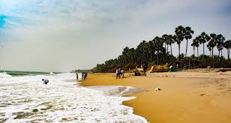


DEPARTMENT OF MULTIMEDIA (VISUAL COMMUNICATION)

DATE: 17. 03. 2025
PHOTOGRAPHY EXHIBITION - 2025
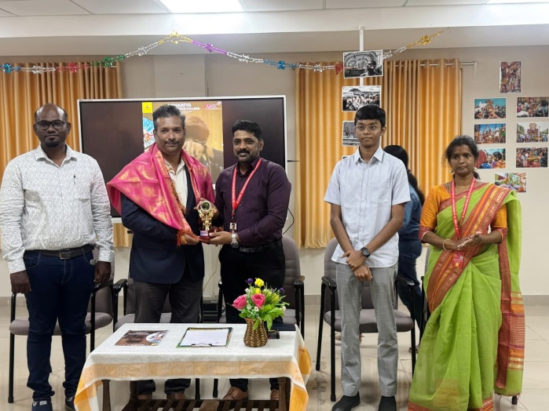
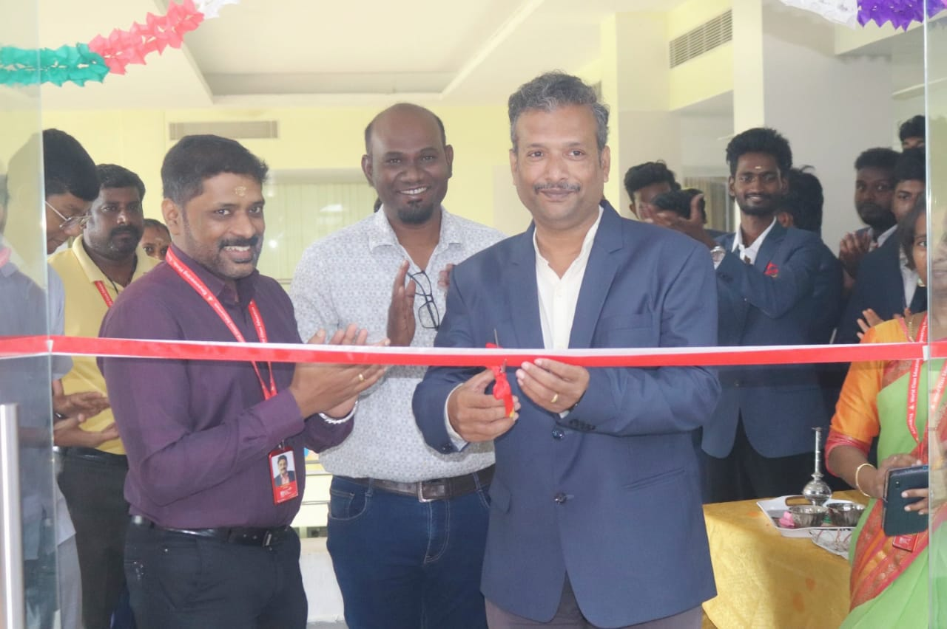
The Department of Multimedia (Visual Communication) successfully organized a Photography Exhibition, Aesthetics of Achariya, on March 17, 2025. The event was inaugurated by our esteemed Chief Guests, Mr. Senthil Joseph from Zion Institute of Photography, Pondicherry, and Mr. Arul Raj from Arul Digital Studio, Pondicherry. Our respected Principal, Dr. S. Vimalanand, addressed the gathering, emphasizing the significance of the exhibition in fostering creativity and artistic expression.
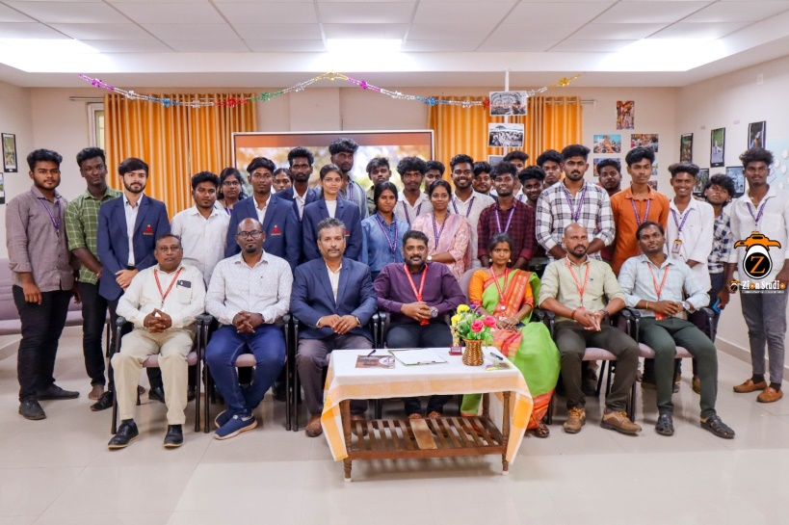
Students and faculty from various departments actively participated, showcasing their exceptional photography skills through a diverse range of exhibits. The exhibition witnessed enthusiastic participation, with around 250 students engaging with the creative works on display and appreciating the artistic perspectives presented.
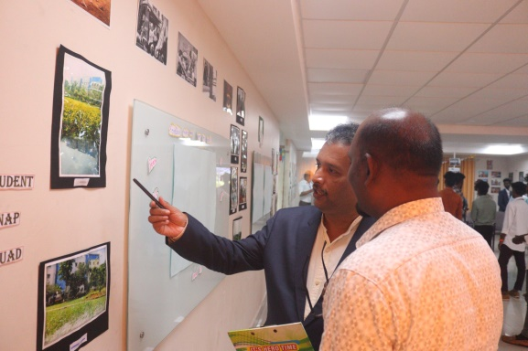



MOU AND GRAND SCREENING
30. 04.2025

The Department of Visual Communication, Achariya Arts and Science College proudly hosted a Grand Film Screening in collaboration with the Rameshwaram International Film Festival (RIFF) on April 30, 2025.
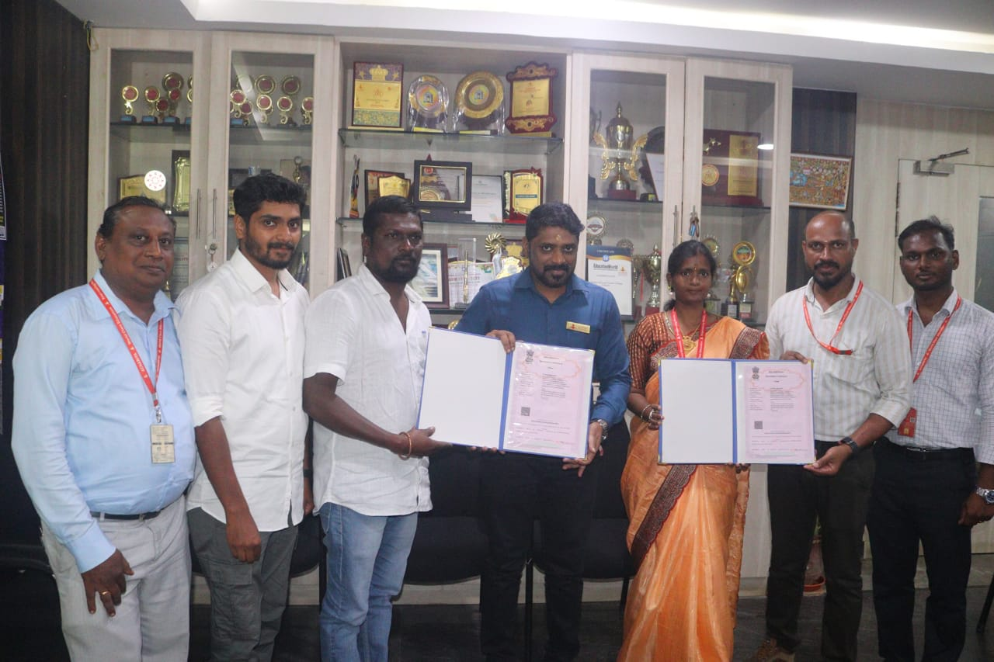
The event provided students with a unique platform to experience diverse cinematic narratives from across the globe and engage with acclaimed international filmmakers.
The event was inaugurated by distinguished Director K. Selvaram, who delivered an inspiring keynote address on the theme “The Importance of World Cinema in Today’s Global Narrative.”
As part of the screening, two impactful international films were showcased:
The Little Moon – Directed by Ali Atshani, United States. Based on real-life events, this Iranian-centered film portrays the youth-led resistance against compulsory hijab laws and the tragic suppression of voices during the recent protests in Iran.
Khadima (The Caregiver) – Directed by Govind K. Saji, India. This Malayalam film narrates the harrowing journey of Janaki, a caregiver from Kerala deceived into working in the Persian Gulf. The film sheds light on the exploitation of migrant workers and the indomitable spirit of caregivers who endure adversity abroad.
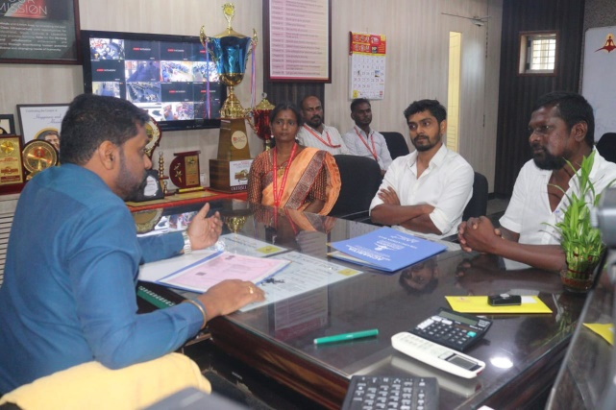
A major milestone of the event was the signing of a Memorandum of Understanding (MoU) with International Global Film Services (IGFS).
This significant partnership aims to promote:
Monthly international film screenings
Virtual interactions with leading filmmakers and industry professionals via platforms such as Skype and Zoom
Proud Moment
Top filmmakers from across the globe joined the session virtually,interacted directly with the Visual Communication students.
The esteemed participants included:
Julian Konczak (United Kingdom)
Juan Carlos Salas Tamez (Mexico)
Mitra Mazumder (India)
Ali Atshani (United States)
Paul Michael Maher (United Kingdom)
Govind K. Saji (India)
James Camery (United States)
GUEST LECTURE
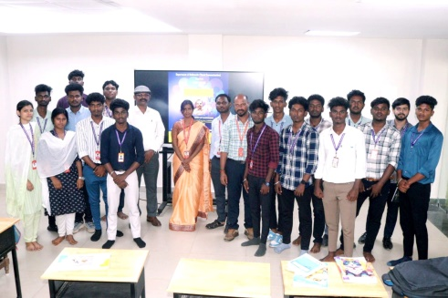
The Department of Visual Communication, Achariya Arts and Science College, organized a guest lecture on 19.02.2025. Subject Expert, Dr. S. Anand Lenin Vethanayagam, Project Director of the ICSSR Research Programme and Associate Professor in the Department of Electronic Media and Mass Communication at Pondicherry University, delivered an insightful session on "The Need for Intercultural Communication in Developing Multicultural Competency." He also elaborated on Forest Theory, Synergy Theory, and various cultural perspectives, highlighting their significance in fostering effective cross-cultural communication.
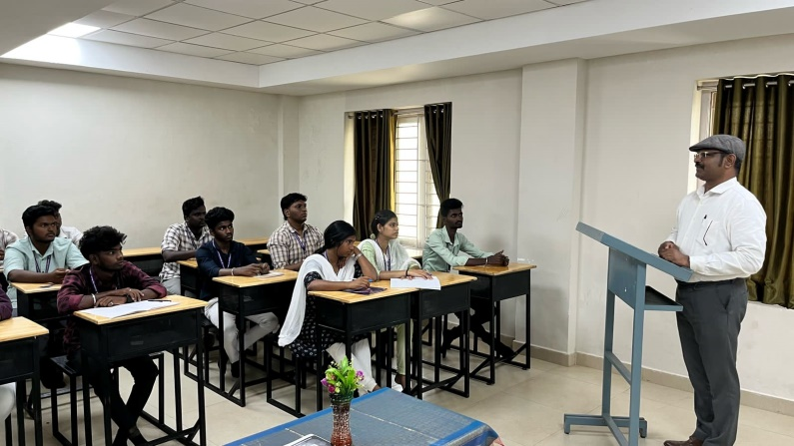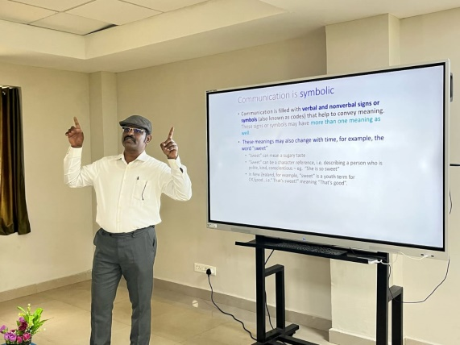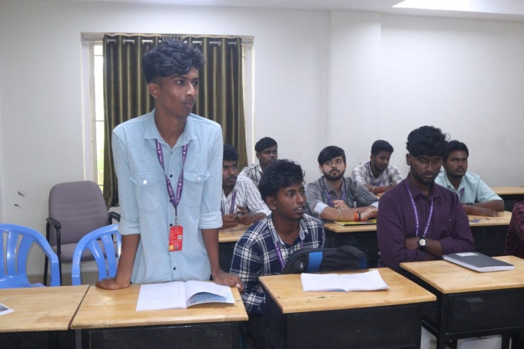

WORKSHOP ON PHOTOJOURNALISM
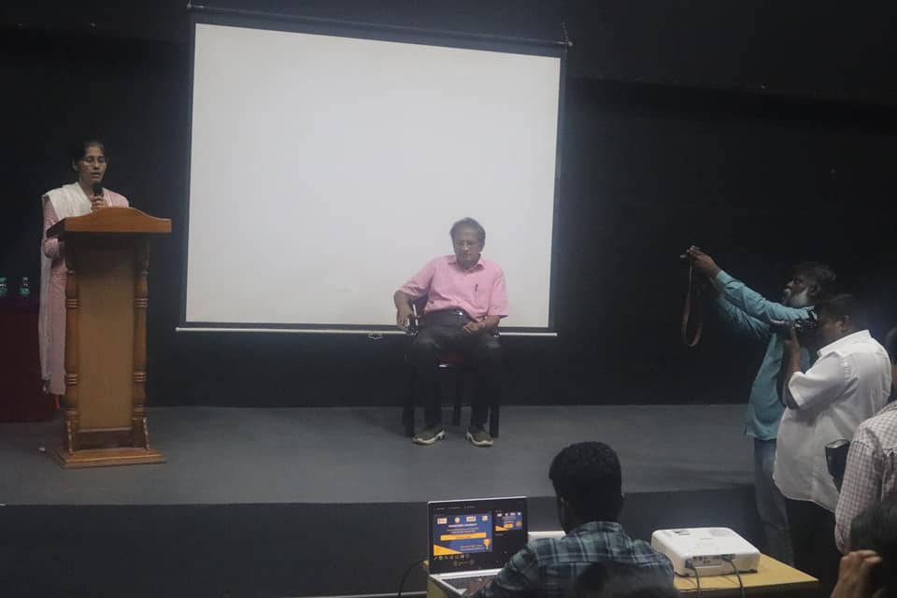
The Department of Visual Communication participated in a *one-day workshop on Photojournalism at Pondicherry University* on 29th October 2024. The workshop was led by *Mr. Pattabiraman, a Renowned Photojournalist*, who shared his extensive knowledge and expertise in the field.
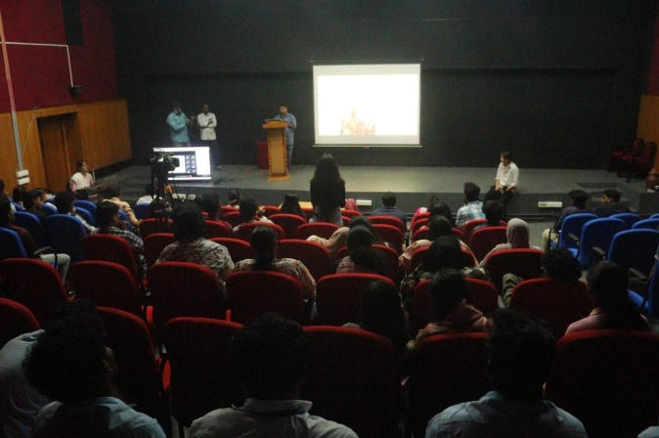
During the session, Mr. Pattabiraman addressed the key aspects of photojournalism, including the art of storytelling through images, ethical considerations in the field, and the evolving role of visual media in modern journalism. His insights into capturing impactful moments, coupled with his real-world experiences, offered students practical and profound knowledge of the subject.
The department would like to express its sincere gratitude to Dr. Radhika Khanna mam, Head of the School of Media & Communication at Pondicherry University, for her generous support in making this enriching experience possible.

The workshop was a resounding success, providing students with a unique opportunity to engage with an industry expert and gain a deeper appreciation for the critical role of visual storytelling in journalism today.

FILM SCREENING
The Department of Visual Communication, in collaboration with the Children's Film Society, organized a special screening of the film entitled SAATHANI on 28.10.24 in our Auditorium. The event aimed to foster awareness and inspire the self-confidence among students, encouraging them to explore their inner innovation and pursue their own goals and determination. Students from all disciplines participated the event in an enthusiastic manner.
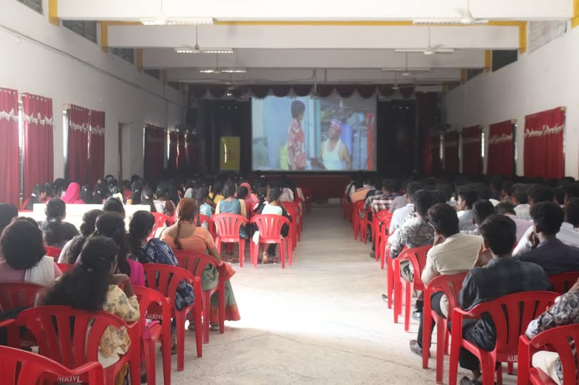

ORIENTATION SESSION
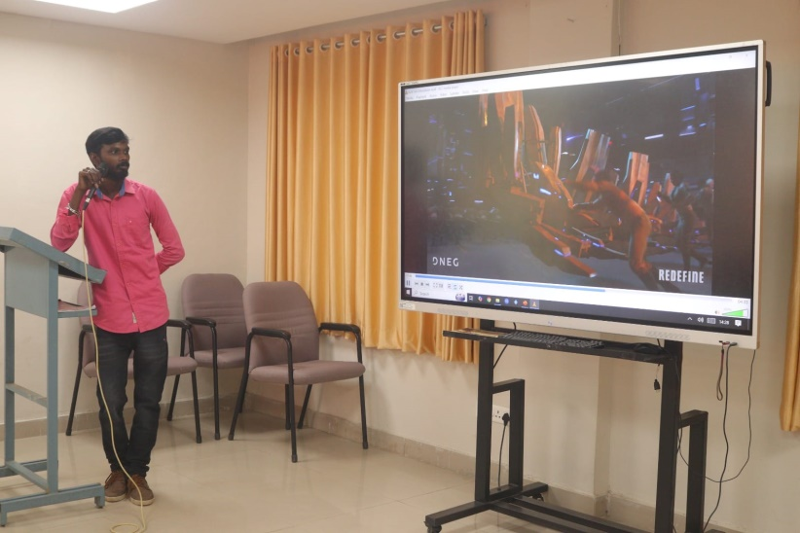
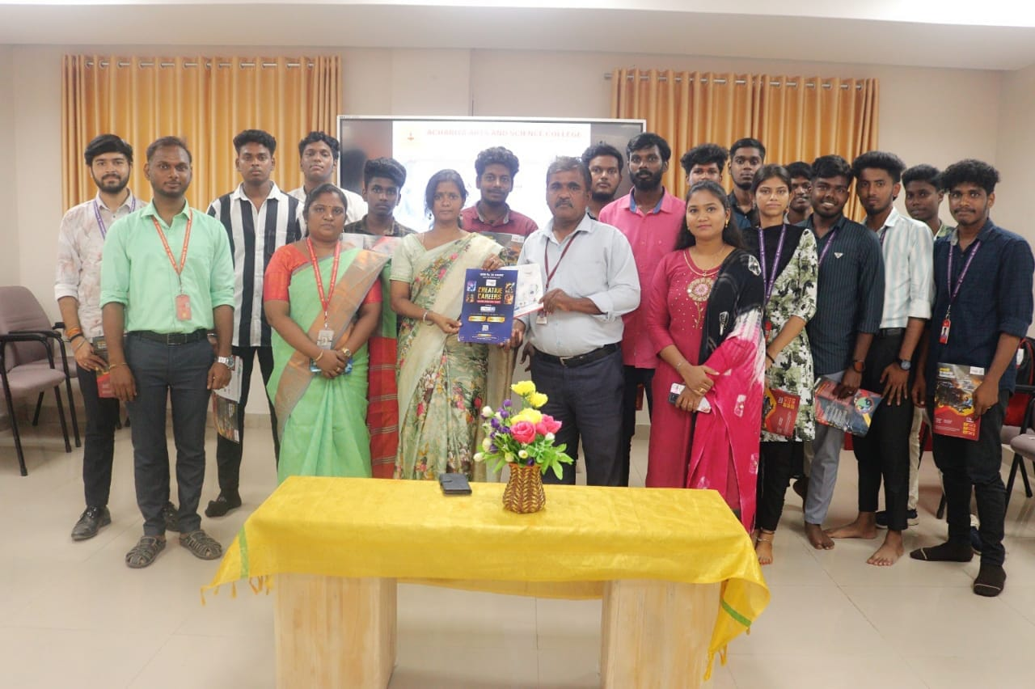
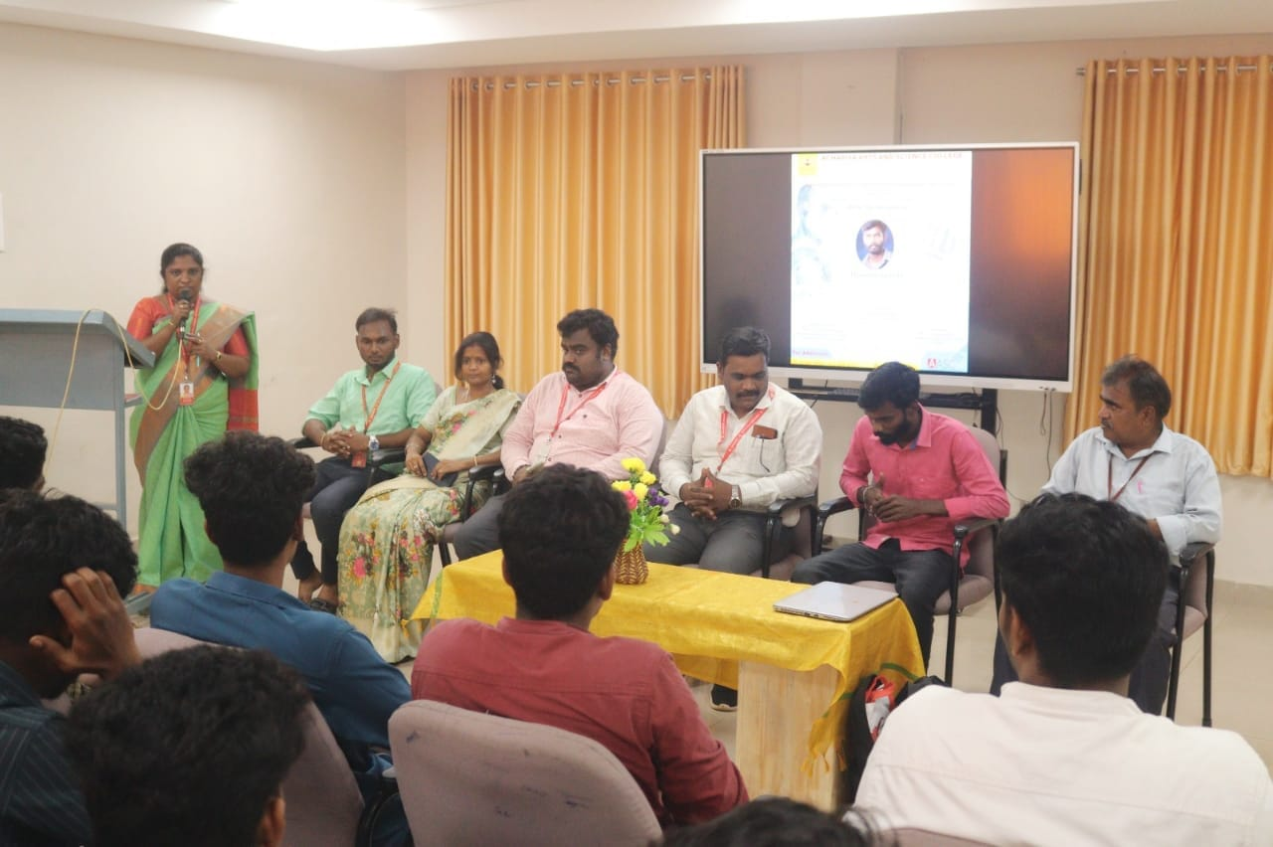
The Department of Visual Communication and Placement Cell of Achariya Arts and Science College, in association with Image Institute, Puducherry, organized a one-day orientation program entitled *Animation and VFX* on 28.11.24 in Conference Hall. The event started with *Mr.* *Thamizhvanan D.* as the resource person, who provided an in-depth exploration of the vast scope and emerging opportunities within the Animation and VFX industry. During his presentation, *Mr.* *Thamizhvanan* highlighted the evolving industry demands, the latest technological advancements, and the diverse career paths available to aspiring professionals. The program aimed to equip students with a clear-cut understanding of industry expectations and inspire them to develop the skills required to excel in the dynamic fields.

